

Assignment: Mid Assignment Date of Submission: 09-09-2024

Course Title: SOFTWARE QUALITY AND TESTING

Course Code: CSC4271 Section: B

Semester: Summer,2023-2024 Course Teacher: ABHIJIT BHOWMIK

**Declaration and Statement of Authorship:**

1. I/we hold a copy of this Assignment/Case-Study, which can be produced if the original is lost/damaged.
2. This Assignment/Case-Study is my/our original work and no part of it has been copied from any other student’s work or from any other source except where due acknowledgement is made.
3. No part of this Assignment/Case-Study has been written for me/us by any other person except where such collaboration has been authorized by the concerned teacher and is clearly acknowledged in the assignment.
4. I/we have not previously submitted or currently submitting this work for any other course/unit.
5. This work may be reproduced, communicated, compared and archived for the purpose of detecting plagiarism.
6. I/we give permission for a copy of my/our marked work to be retained by the Faculty for review and comparison, including review by external examiners.
7. I/we understand that Plagiarism is the presentation of the work, idea or creation of another person as though it is your own. It is a formofcheatingandisaveryseriousacademicoffencethatmayleadtoexpulsionfromtheUniversity. Plagiarized material can be drawn from, and presented in, written, graphic and visual form, including electronic data, and oral presentations. Plagiarism occurs when the origin of them arterial used is not appropriately cited.
8. I/we also understand that enabling plagiarism is the act of assisting or allowing another person to plagiarize or to copy my/our work.

*\* Student(s) must complete all details except the faculty use part.*

** Please submit all assignments to your course teacher or the office of the concerned teacher.

Group Name/No.:

|  |  |  |  |  |
| --- | --- | --- | --- | --- |
| **No Name** | | **ID** | **Program** | **Permit no.** |
| 1 | Nammi, Lamyea Farha | 21-45410-3 | BSc CSE |  |
| 2 | Abiad,Tauhid | 18-39116-3 | BSc CSE |  |
| 3 | Mohammad Bin Harun | 21-44583-1 | BSc CSE |  |
| 4 | Taiyaba Akther | 20-43189-1 | BSc CSE |  |

|  |  |  |
| --- | --- | --- |
| ***Faculty use only*** |  | |
| FACULTYCOMMENTS | **Marks Obtained** |  |
|  |
|  |
|  | **Total Marks** |  |
|  |
|  |

**1.JDK Setup – At first, we will download JDK because we will be using java for testing a program.**

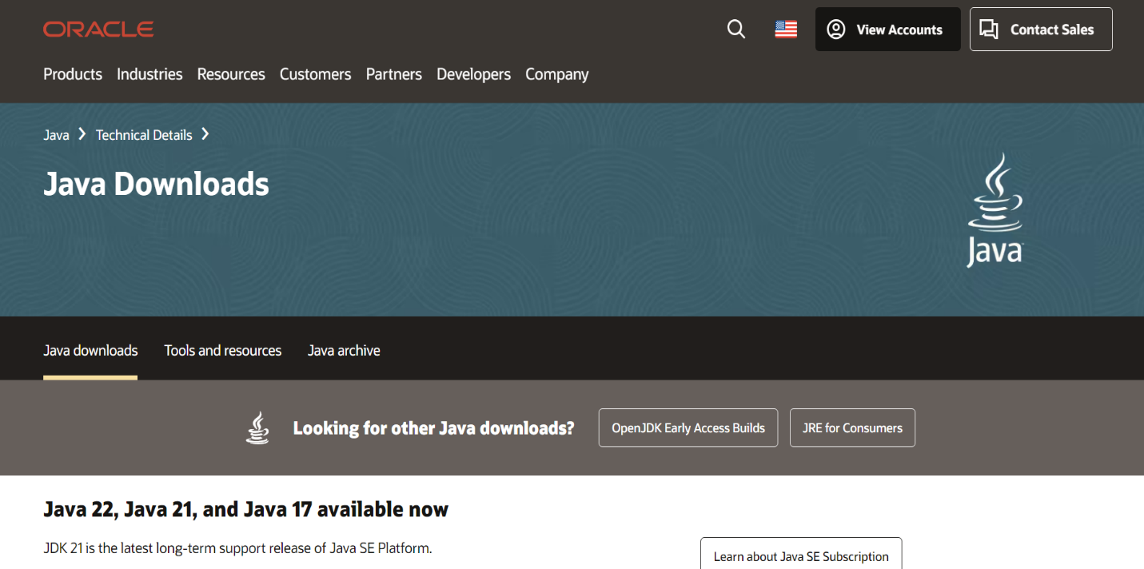

**2. Setup path**

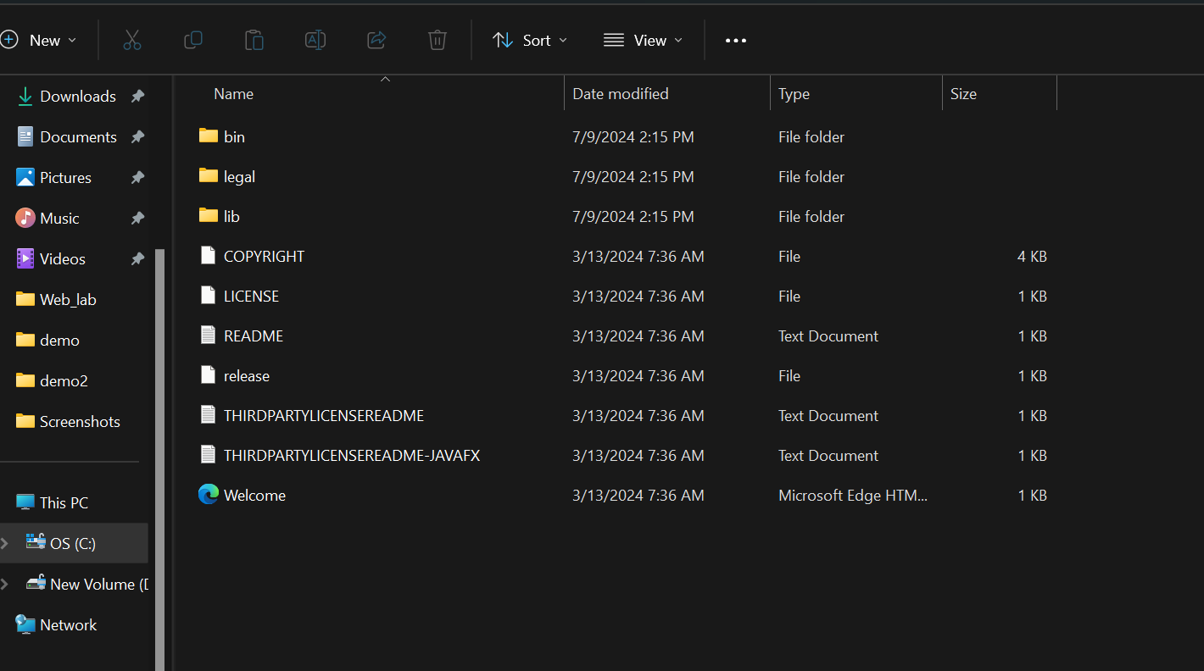

**3. Check the version of JDK**

**4. ECLIPS Download**

**5. ECLIPS Setup:**

**6. Download Selenium**

**7. By clicking on New, we can start a new Java project**

**After writing a project name and selecting the default JDK, we can click Finish button**

**Now, we need to add the selenium jar files into our project file. Right click on the project file, go to build path and then click on configure build path.**

**Click on Libraries, then the Class path and after that click on Add External JARs to add the selenium jar files.**

Now we need to click apply and close.

**Let’s create a class to write our code to test. Here we will be using the Login and Registration page of our Web project.**

**Give the name of the package, class and then click finish.**

**Testing**

**# Main Function:**

**1.Login Test:**

**2.Admin Login:**

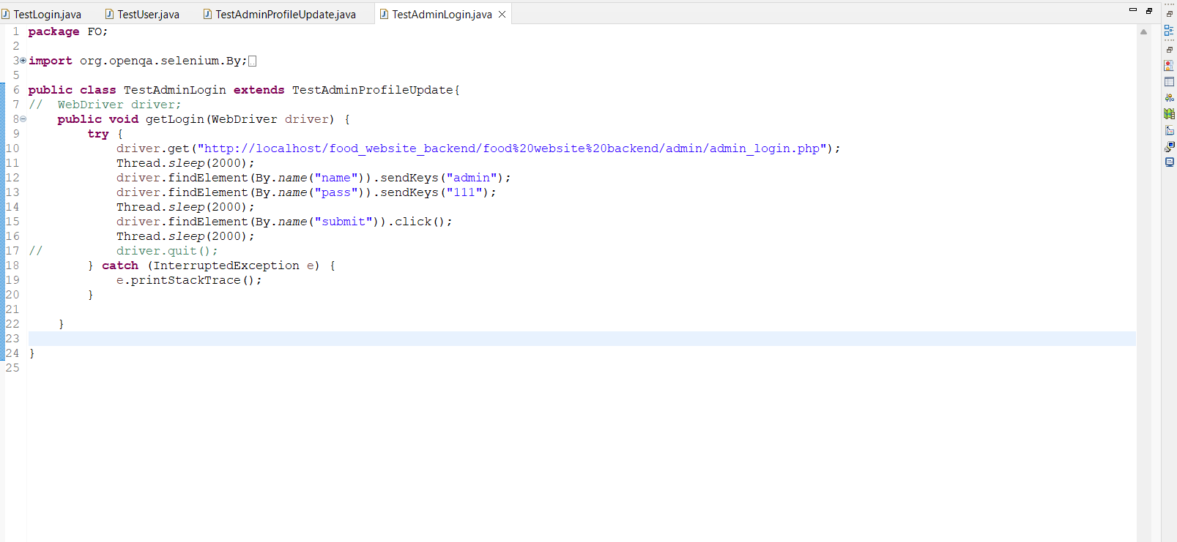

**3.Update Test:**

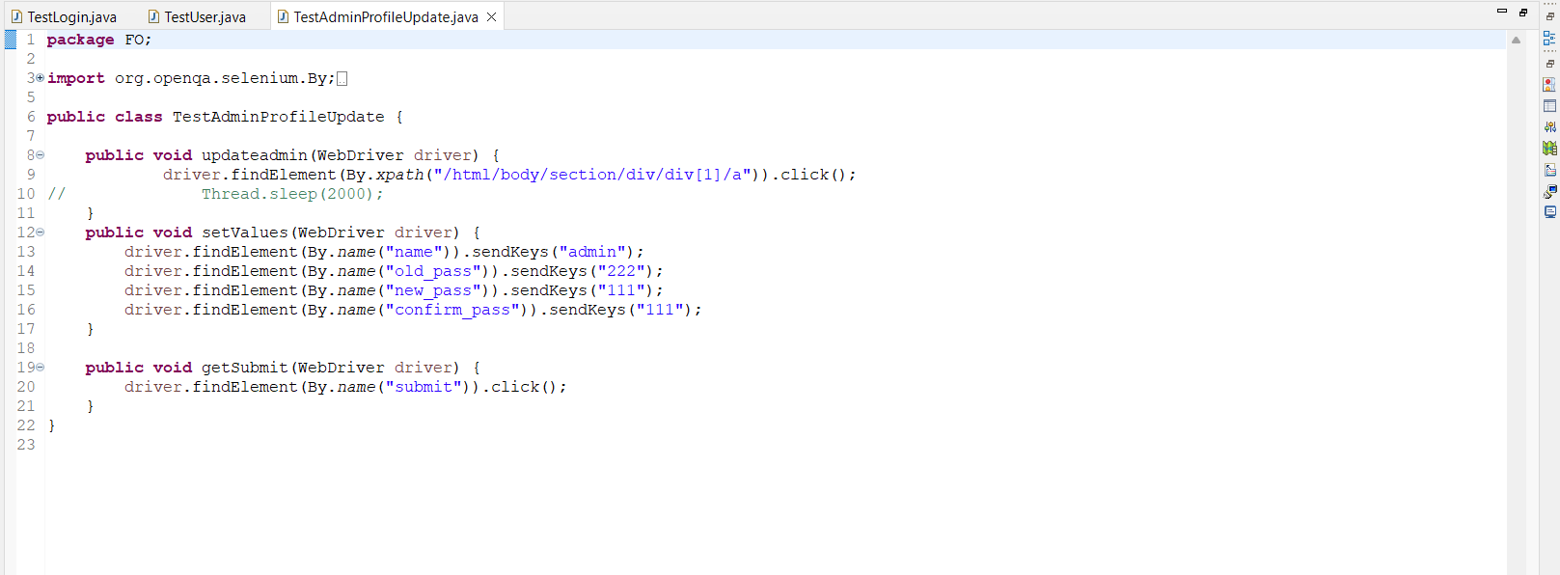

**5.USER TEST:**

**6.Product Test:**

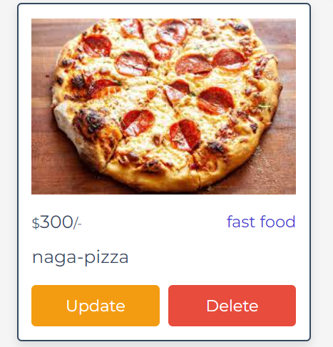

**7.Menu:**

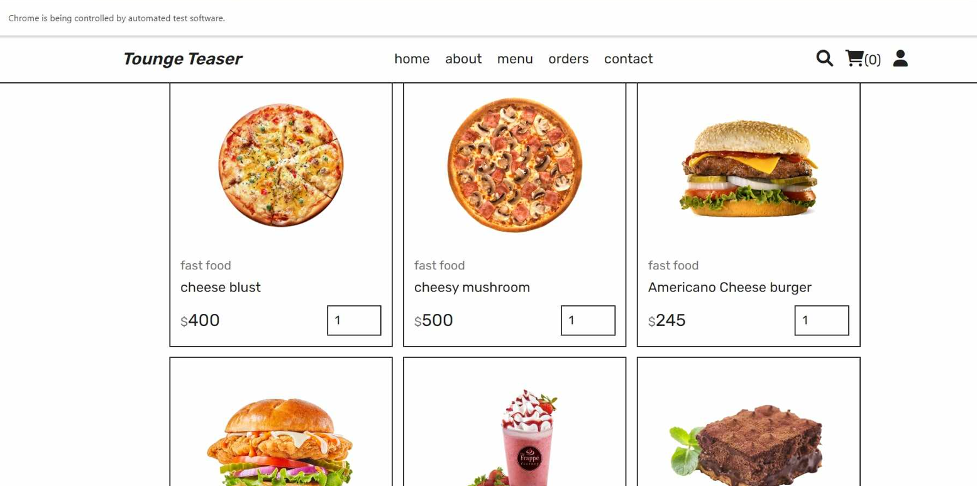

**8.Order:**

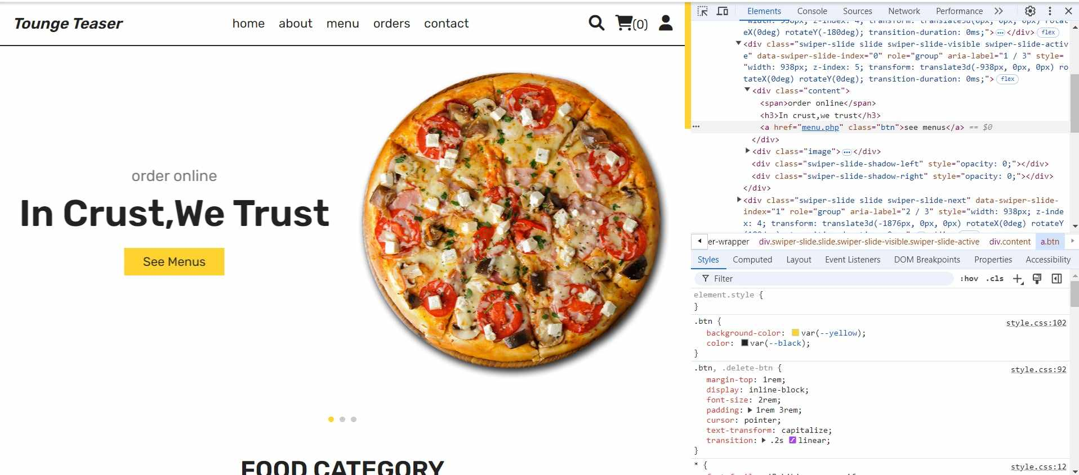

**9.Contact:**

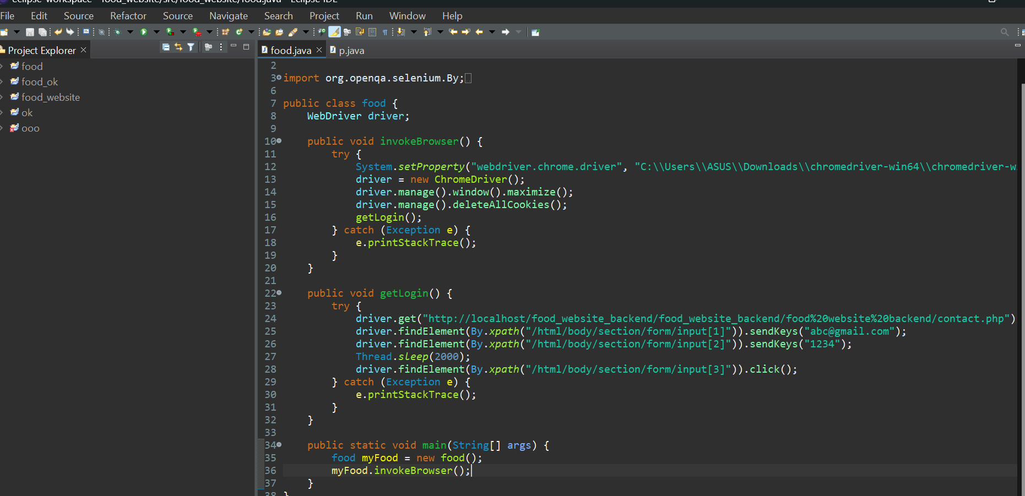

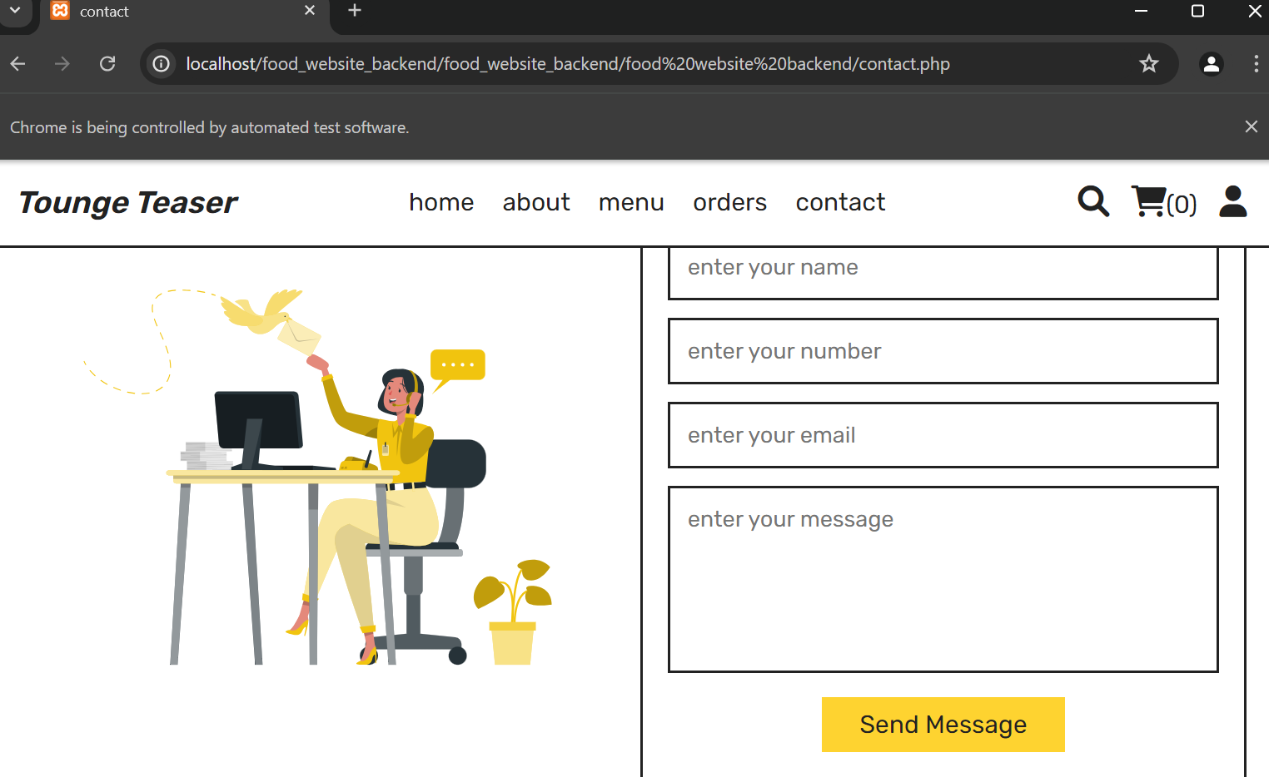

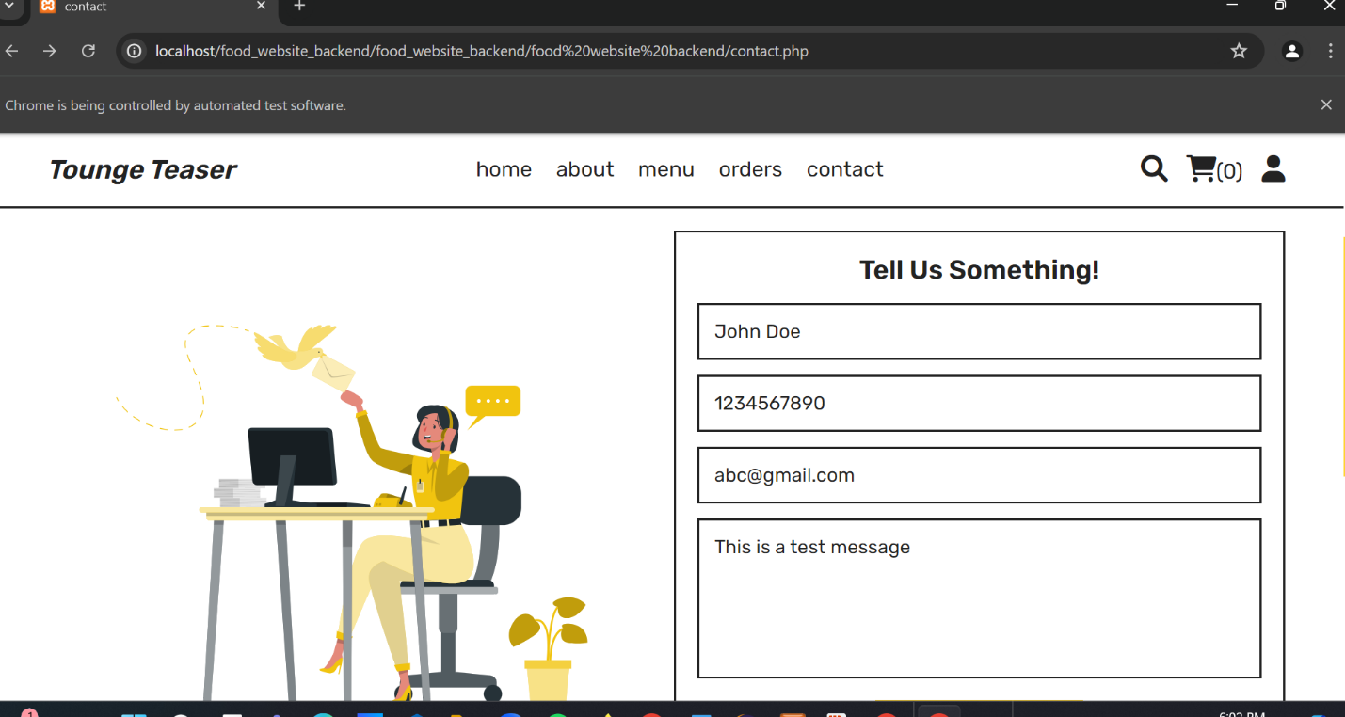

**10.Already Send a Massage:**

**11. Checkout:**

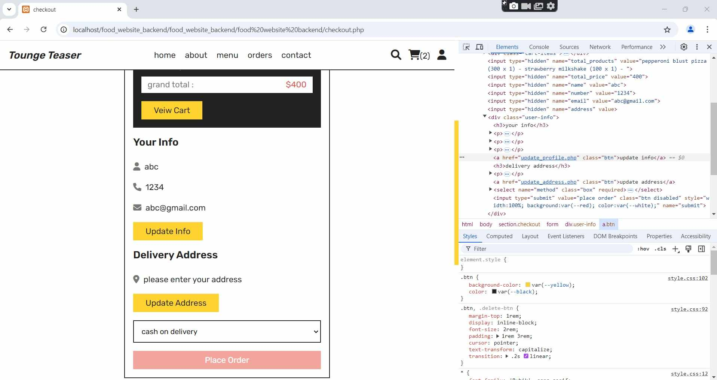

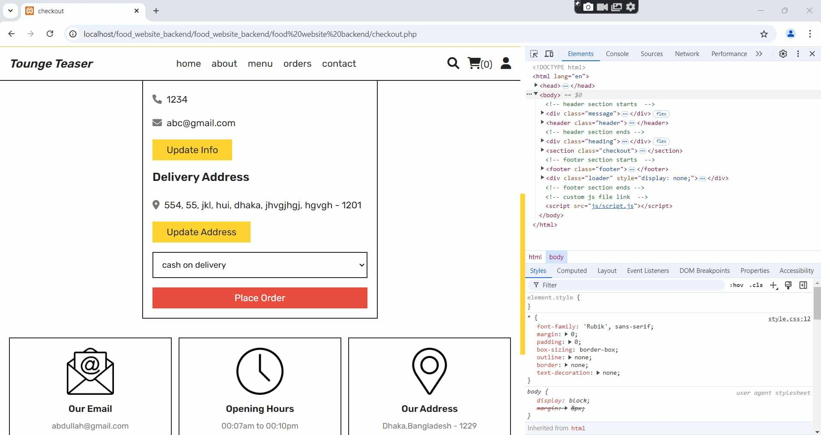

**12.Cart:**



